**EKT 720 Assignment 7**

***Question 2***

1. Partial program:  
   **proc** **logistic** data=sev.model outdesign=des1;

class d3sc d8s gmesc nd5s q50b_7s q55as ;

model rq34_1s = d3sc d8s gmesc nd5s q50b_7s q55as/lackfit outroc=sev.graph ;

**run**;

1. Relevant output:

| **B_new** |  | **err** |
| --- | --- | --- |
| intercept | 2.6956287 | 1.277E-15 |
| d3sc 10-11 | -0.147744 |  |
| d3sc 12-13 | 0.132253 |  |
| d3s 14-15 | 0.1050745 |  |
| d8s 1 | -1.339393 |  |
| d8s 2 | 0.0308078 |  |
| d8s 3 | 0.7276815 |  |
| gmesc High | 0.2210477 |  |
| gmesc Low | -0.39982 |  |
| q55as 0 | -0.413795 |  |
| q50b_7s 0 | 0.1013721 |  |
| nd5s 1 | -0.182334 |  |
| nd5s 2 | -0.200414 |  |

1. Using the “lackfit” option in proc logistic, the following ROC curve was obtained:

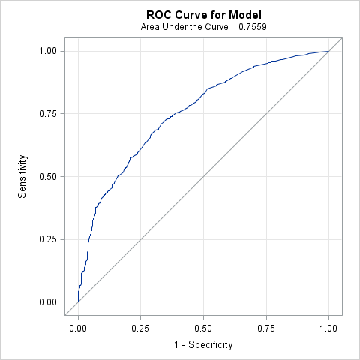

1. The model measures the probability of being friends with someone who has HIV/AIDS. The explanatory variables include different age groups, races, level of media exposure to HIV/AIDS and other categorical variables that result in a binary response variable. Using the ROC curve, the probability of being friends with someone with HIV/AIDS is close to 1. The estimated parameters have a partial effect on the overall probability, holding all other parameters constant.